1. **CUSTOMIZED OFFICE WORSTATION WITH FILE DRAWERS COMPUTER CUBICLES.**

low office partition / cubicles / workstation fabric with glass(stripe frosted sticker) wooden mobile pedestal , CPU rack & keyboard tray customize colors panel thickness : Bullet Series / 3.2cm Php 35,200.30 DELIVERY AND INSTALLATION INCLUDED (METRO MANILA) ***CHAIRS AND OTHER ACCESSORIES NOT INCLUDED This system can be in many different configuration. Prices are inclusive of VAT

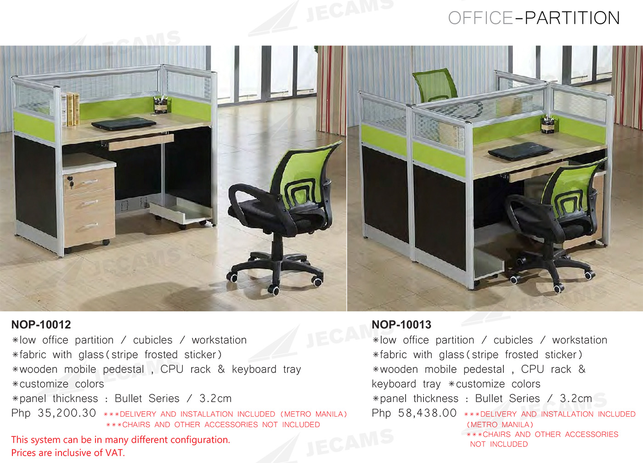

COMPANY NAME : JECAMS COMPANY.

More details.

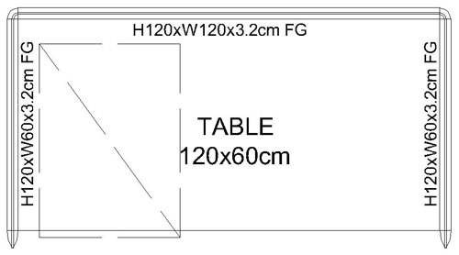

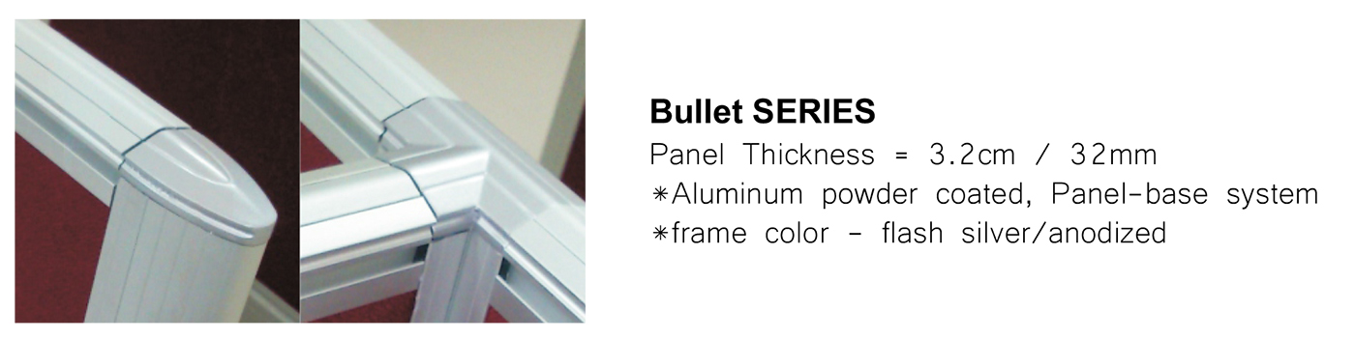

FOB Price : US $100 / piece

Min order : 5 pieces

Port : yiwu

Payment terms : Alipay, moneygram, wechat money..

Phone number : 13175508115

Email : [wyc@gmail.com](mailto:wyc@gmail.com)

We are advertizers of this company and in the case of advertizing we get paid by the number of purchased items. The more customers buy the more commission we get.

1. **DECENT LUXURY CABINETS FOR KITCHEN WITH PARTICLE BOARD.**

72 Great Suggestion Cream Maple Glaze Kitchen Cabinets With Chocolate Drawer Slides For Best Wood Cabinet Doors Stain Fireproof Suncoast Supply Dark Floors Jacks Can You Paint Particle Board Wallpaper Digitals

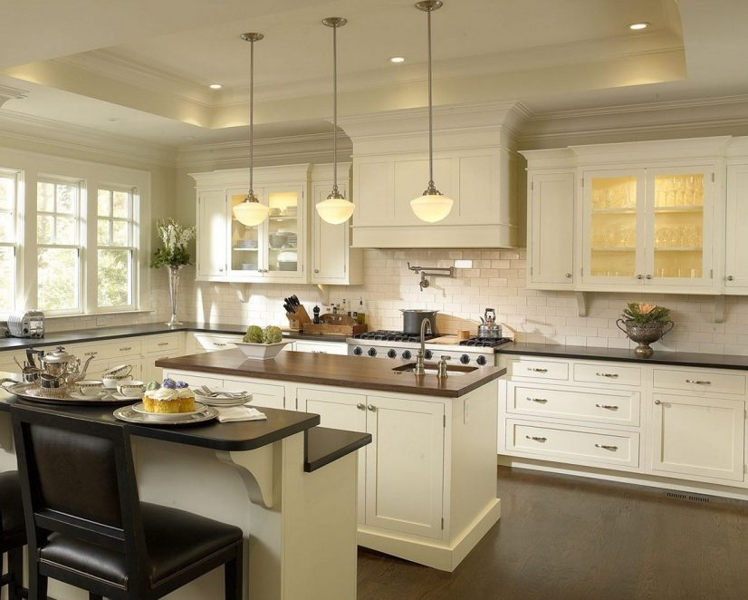

Kitchen cabinets have many purposes. Not only do they hold appliances, dishes, and food, they also bring the essential style to the kitchen. Buying kitchen cabinets can be expensive and difficult, but understanding the different cabinet options on the market and finding reputable kitchen cabinet distributors will be able to get a beautiful kitchen without breaking the bank.

Published at Wednesday, January 24, 2018, 15:54:37 by Fredriksson Clarimunda in **Cabinets**, with total 72 imageries.

Rustic Kitchen: The rustic cabinets are manufactured by using wood like hickory, knotty pine or alder that is heavily grained. There is a flat panel door system available in these cabinets. Some of the common color stains available in the rustic cabinets are yellow, red and green.

The price of the cabinets: When you are buying the kitchen cabinets, you need to find the best deals on the cabinets. You can either ask for the kitchen accessories along with the kitchen cabinets or you can ask for the free installation of the cabinets.

MIN ORDER :AS MUCH AS YOU WANT

LOCATION : YIWU

PAYMENT : UNION PAY , WESTERN UNION, MONEYGRAM.

PHONE NUMBER : 13548799541

EMAIL : hughbriss.yahoo.com

COMPANY : HUGHBRISS KITCHEN CARBINET IDEAS

# 3.Marble Top Dining Table Modern Design Stainless Steel Dining TableImage result for Mordening dining room furniture marble top stainless steel dining table

# Purchase qty: 5-9

# FOB price : US $180

# Port : Shenzhen, china

# Producttion capacity: 1000piece/month

# Payment terms ; L/C, T/T, Western union

Marble Top Dining Table Modern Design Stainless Steel Dining Table

|  |  |  |  |
| --- | --- | --- | --- |
| Product name | marble top stainless steel leg dining room table and chairs designs | | |
| Item No | 868# | | |
| Size(cm) | 150*90*75cm | | |
| material | stainless steel frame, marble or 12mm tempered glass | | |
| packing | 4ctnS/PC | | |
| CBM(m3 ) | 0.22 | | |
| G.W(kg) | 128 | | |
| Container capacity | 40'HQ | 40GP | 20GP |
| 309pcs | 263pcs | 127pcs |
| MOQ | 5pcs for each model | | |
| Delivery time | Trial order lead time:10-15days. | | |
| Formal order lead time:15-20days. | | |
| Payment terms | T/T or L/C,30% deposit before production, the balance be paid before delivery | | |
| Loading port | Shenzhen/Guangzhou | | |

**Basic Info**

* Model NO.: 868#
* Material: Stainless Steel+Glass/Marble
* Shape: Rectangle
* Rotary: Fixed
* Customized: Customized
* Factory City: Foshan City
* OEM: Accept
* Glass: 12-15mm Tempered Glass
* Stainless Steel: 1.2mm 201 Stainless Steel
* Steel Color: Gold , Blue , Gray , Brushed,White
* Trademark: Qiancheng Furniture
* Specification: 150*90*75cm
* HS Code: 9401790000
* Style: Modern
* Usage: Hotel, Home
* Folded: Unfolded
* Color: Sliver /Golden
* Condition: New
* Busineess Type: Manufacturer
* Matercial: 201# Stainless Steel Frame+Glass/ Marble Top
* Marble: 20-40mm Artificial Marble
* Glass Color: Black , Different Pattern , Frosted
* Warranty: 2 Years
* Transport Package: Standard Export Carton Packing
* Origin: Foshan City, Gd. China

4.office furniture wooden MDF executive desk manager table office boss table

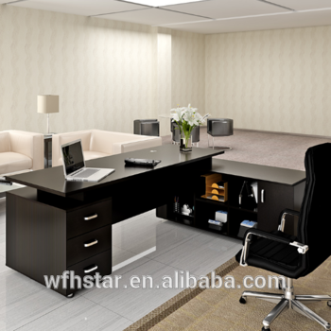

MATERIAL ACCESSORY

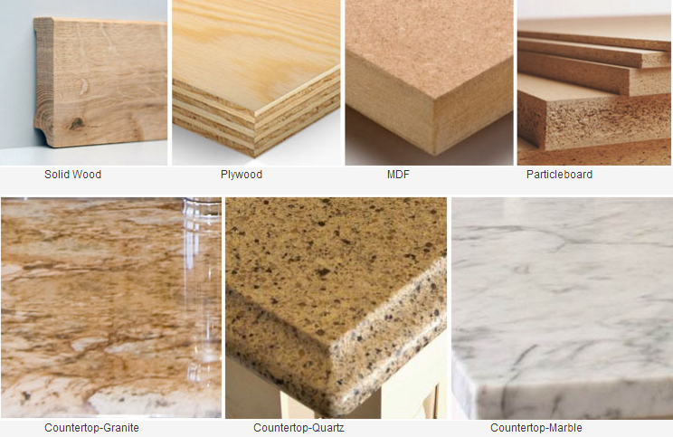

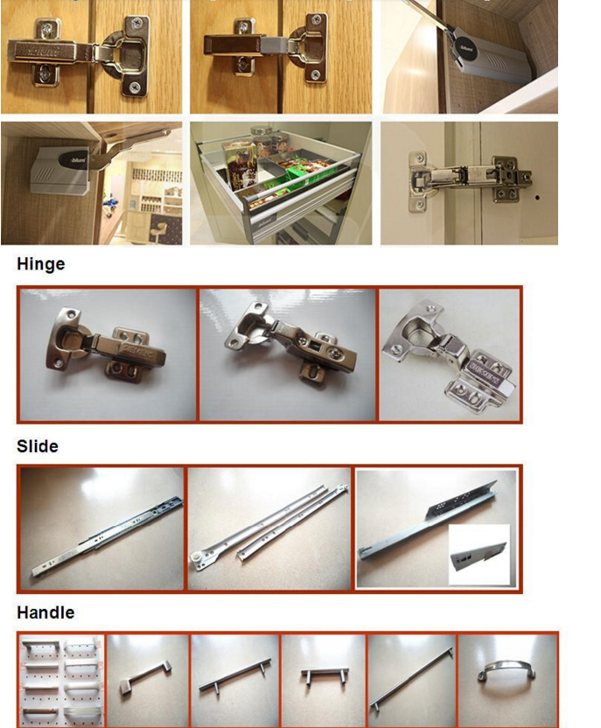

**Overview**

**Quick Details**

Type:

Office Furniture

Specific Use:

Office Desks

General Use:

Commercial Furniture

Material:

Wooden

Wood Style:

Panel

Panel Type:

MDF

Appearance:

Modern

Size:

Customer's Requirement

Place of Origin:

Shandong, China (Mainland)

Brand Name:

H.STAR

Model Number:

wooden MDF executive desk manager table office boss table

Product Name:

wooden MDF executive desk manager table office boss table

Color:

soild color or wooden grain

Feature:

Smooth

Style:

Modern Work Office Desk

Application:

Office Hotel Home

Design:

Morden Office Fruniture

Warranty:

1 Year

Service:

OEM ODM

Name:

Boss office table/computer desk

|  |  |
| --- | --- |
| Name | office furniture wooden MDF executive desk manager table office boss table |
| material | MDF,Plywood,Particle board,Blockboard |
| Finish | Melamine paper,High gloss UV,Acrylic,PVC,etc |
| Size | OEM |
| Color | OEM |
| Packing | Inner packing  (Plastic bag,Bubble  material) |
| Standard export carton  (bear 50 KGS or more,7K thicker carton)   (Puller Strap outside) |
| MOQ | >10 sets |
| Terms of  payment | T/T (30% in advance and the balance before loading from the factory) |
| LC |
| WESTEN UNION |
| Sample fee | 2 times of unit price |
| Sample time | 20 days after sample charge received |
| Delivery time | 20-25 days after deposit received  According your qty and products |
| Loading port | Qingdao,China |
| guarantee | 5-10 years |
| Style | Simple / unique /modern |
| Use | Clothes / trousers / bag / coat / shoe display, clothes store fixture,shop fitting |
| Superiority | Every products is designed with fashion & modern by our own designer |
| No Mould fee if you choose our own design |
| your own design could be produced by us |
| Competitive price .high quality .quick delivery |
| Best service, especially after-sale service |
| OEM |

FOB Refernce : Get latest price

US $ 15-60 / set 500 set/sets(Min. order)

Supply ability: 10000 set/sets per month

Port: Qingdao

Shipping: Less than a container load(lcl) service to US shipping quote.

Payment: visa, union pay, TT, e-checking

[Alibaba Group](http://www.alibabagroup.com/en/global/home) | [Taobao Marketplace](http://www.taobao.com/) | [Tmall.com](http://www.tmall.com/) | [Juhuasuan](http://ju.taobao.com/) | [AliExpress](http://www.aliexpress.com/) | [Alibaba.com International](http://www.alibaba.com/) | [1688.com](http://www.1688.com/) | [Alimama](http://www.alimama.com/) | [Fliggy](https://www.fliggy.com/) | [Taobao Global](https://world.taobao.com/)   
[Alibaba Cloud](https://www.alibabacloud.com/) | [AliOS](http://www.alios.cn/) | [AliTelecom](http://aliqin.tmall.com/) | [HiChina](http://www.net.cn/) | [Autonavi](http://www.autonavi.com/) | [UCWeb](http://www.uc.cn/) | [Umeng](http://www.umeng.com/) | [Xiami](http://www.xiami.com/) | [Diandianchong](https://www.laiwang.com/) | [DingTalk](http://www.dingtalk.com/?lwfrom=20150202135600390) | [Alipay](https://intl.alipay.com/index.htm) | [Lazada](http://taobao.lazada.sg/)

# 5. Classic Bedroom Furniture Set with Classic Bed (6618)

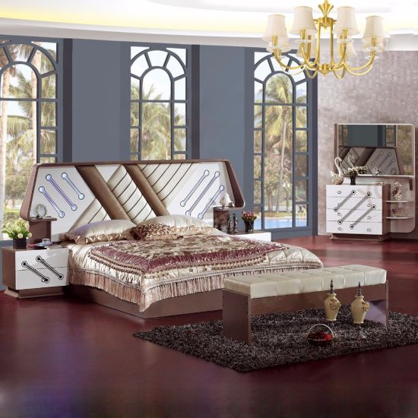

## Product Description

Foshan Shunde YiFan Furniture Co., Ltd, located in Furniture center of Foshan City of Guangdong Province, is specially in manufacturing Sofa, Bedroom Furniture, Living Room Furniture, Home Furniture and Wood Furniture, which is a private enterprise with numerous eligible proficient craftsmen, advanced equipments and sophisticated administrators  
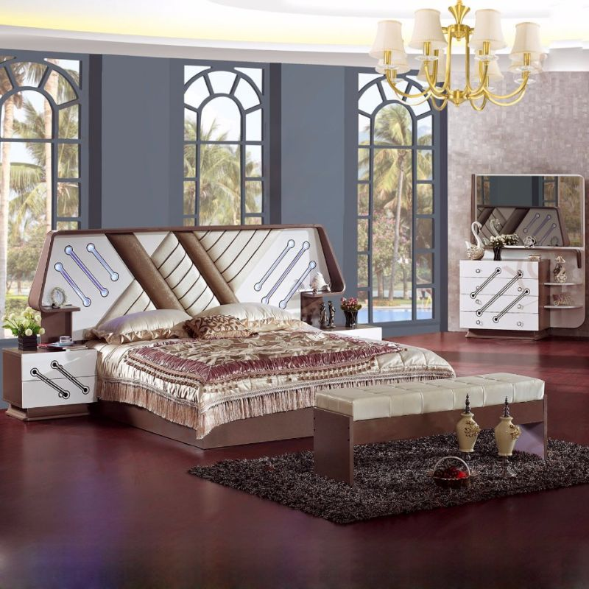  
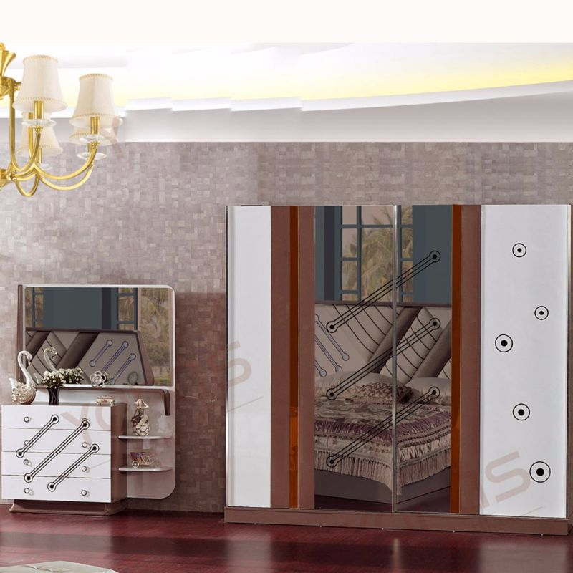  
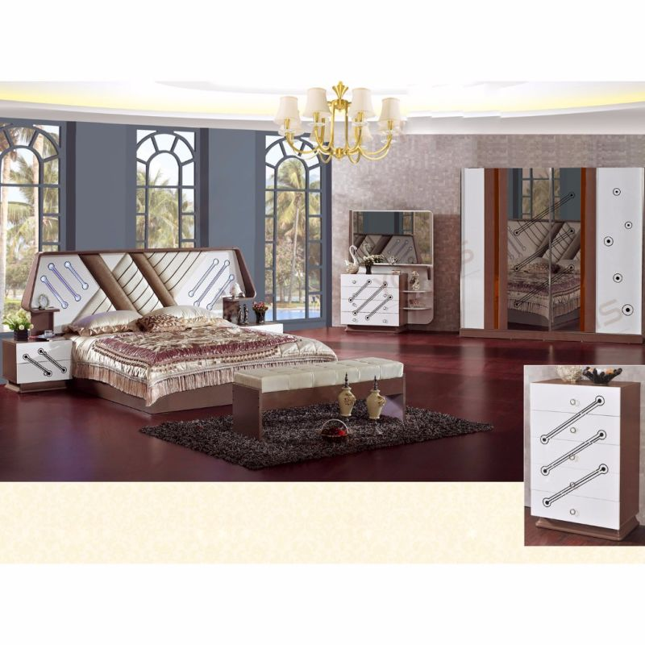

## Basic Info

Model NO.: YF-6618

Disassembly: Disassembly

Height Adjustable: Unadjustable

Shape: Square

Color: Red

Customized: Non-Customized

Washable: Washable

Condition: New

Top Coat: Sealed PU Paint

Primary Coat: PU Paint

Mixed Container Order: Accepted

Cleaning: No Water Washable (Directly)

Cubic: 1.8

Stock: No

Warning: Avoid Direct Sunshine

Mixed Model: Accepted

Shipping Service: Accepted

LCL Order: Accepted

Trademark: Star Home

Transport Package: Knock Down

Specification: European

Origin: China

HS Code: 940359000

Min order: 17 sets

Port: Guangzhou, china

Payment terms: TT, western union, Moneygram

Production capacity: 900 sets/months

Size : double

Style: antique

Phone number: 18725568447

Email: [forshancompany@yahoo.com](mailto:forshancompany@yahoo.com)

Factory: **Foshan Shunde YiFan Furniture Co., Ltd.**

NAME OF SUPPLIER: Mr. Darell.

**Package:** Knock Down  
  
**Transportation Way:** Sea Transportation and International Multiple Ways  
  
**Place of Receipt:** In Factory or Customer Appointed  
  
**Port of Loading:** Shenzhen Port or Customer Appointed  
  
**Shipping Transportation:** Client Appointed or Factory Arrangement  
  
**Payment Term:**T/T, Western Union, Money Gram  
  
**Produce Time:** Within 35 Days in Peak Seasons and 23 Days in Normal Seasons  
  
**Loading Container:** 30% Deposit and Payment Balance before Delivery

|  |  |  |  |
| --- | --- | --- | --- |
| Trade Term | Place of Receipt | Loading of Port | Shipping Cost |
| EXW | In Factory or All Places of China |  | Buyer |
| FOB | In Factory or All Places of China | Shenzhen Por or Customer Appointed | Buyer |
| CFR | In Factory or All Places of China | Shenzhen Por or Customer Appointed | Factory |
| CIF | In Factory or All Places of China | Shenzhen Por or Customer Appointed | Factory |
|  | | | |
| Type of Container | | Container' s Accomodation | |
| 20' GP Container / 20' Feet General Purpose Container | | 17 Sets Per 20' GP Container | |
| 40' GP Container / 40' Feet Dry Freight Container | | 33 Sets Per 40' GP Container | |
| 40' HC Container / 40' Feet High Cube Dry Container | | 43 Sets Per 40' HQ Container | |
|  | | | |
| Model | Item | Size (millimeter) | Quantity (piece) |
| YF-6618 | Classical Bed | 2630*2080*1290 | 1 |
| YF-6618 | Night Stands | 560*415*470 | 2 |
| YF-6618 | Wardrobe | 2400*605*2200 | 1 |
| YF-6618 | Dresser Table | 1220*465*1660 | 1 |
| YF-6618 | Five Drawers Chest | 700*400*1080 | 1 |